**Introduction** **1**

**Fuse** **2**

**Equipotential** **2**

**Earthing Systems** **4**

**Example One Trunking calculation:** **5**

**Example one: Conduit Calculations** **8**

**Final example Conduit calculation** **12**

**Practical workshop write-up Section** **15**

**Picture of the board** **16**

**Testing R1 + R2 - How does the Fuse board look?** **17**

# Introduction

Fuse factor is how many times more than it’s rating will it trip.

TN system does not matter if it is TNS or TN-C-S

TT systems have to trip faster.

# Fuse

The primary job of a fuse is overload protection.

Secondary job of a fuse is fault protection (**live** touches **Neutral**, **Live** touches **Earth**)

**First Example**

A kettle uses 2 kilowatts of electricity.

The current is 8.7.

The Fuse rating is 13 A.

I = P/V.

—-------------------------------

**Second example**

218.5 (Cmin)/30(B6 circuit breaker size) = 7.28

7.28 X 0.8 = 5.824 (0.8 accounts for heat loss if the cable is cold to begin with)

—------------------------------

You do not need an RCD on every circuit. RCD provides additional protection and will trip at 30 milliamps to earth.

# Equipotential

Electricity only flows when there is a difference in voltage.

In a shower room there is a risk that the user could touch a radiator and electric shower at the same time. Both of these devices have different voltages. This could lead to an electric shock. Therefore, to overcome this all the devices were **Earthed**. This meant that they would all have the same voltage and would mean that the user would not receive an electric shock.

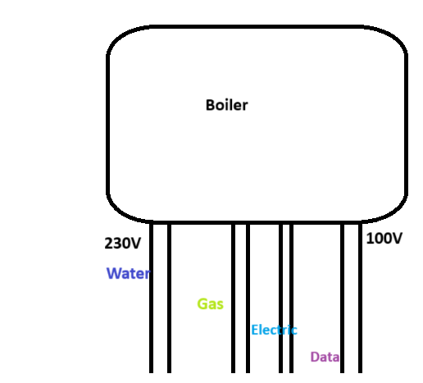

If someone touched the first and last pipe they would receive a shock of voltage of 130V.

Because, that is the difference between the pipes. 230V - 100V = 130V

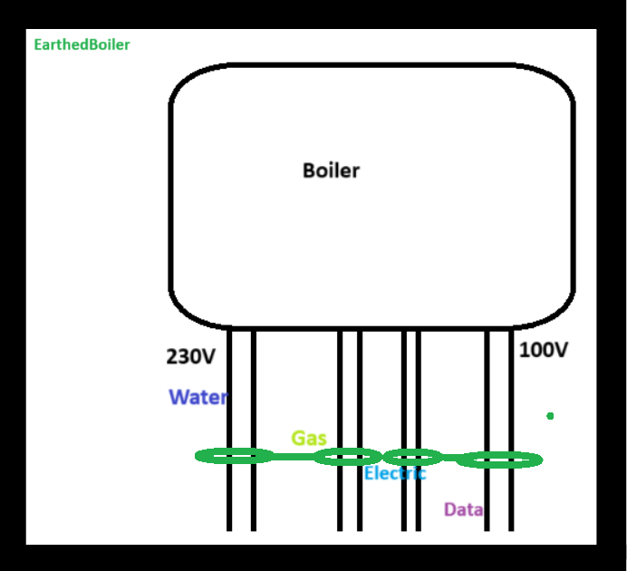

No potential difference - therefore no electrical shock.

# Earthing Systems

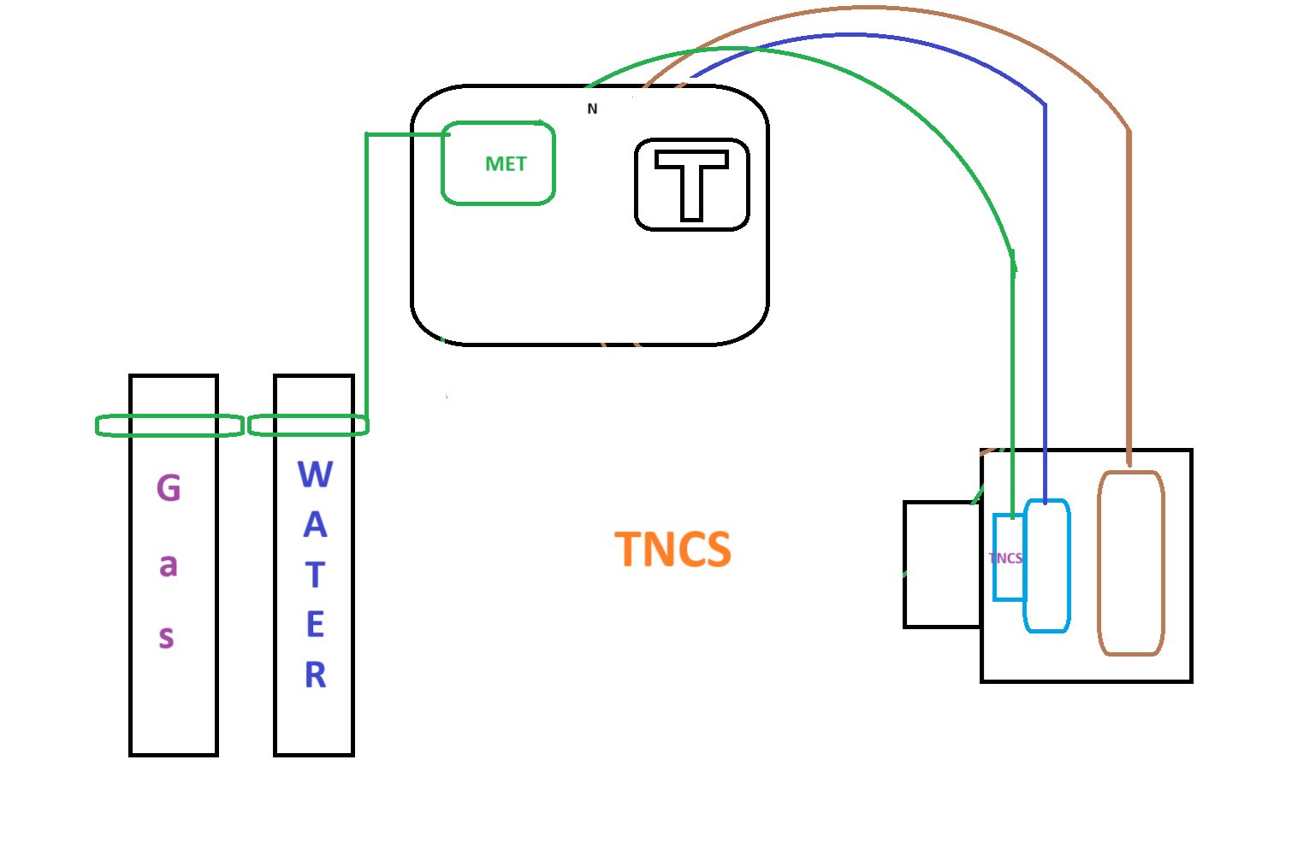

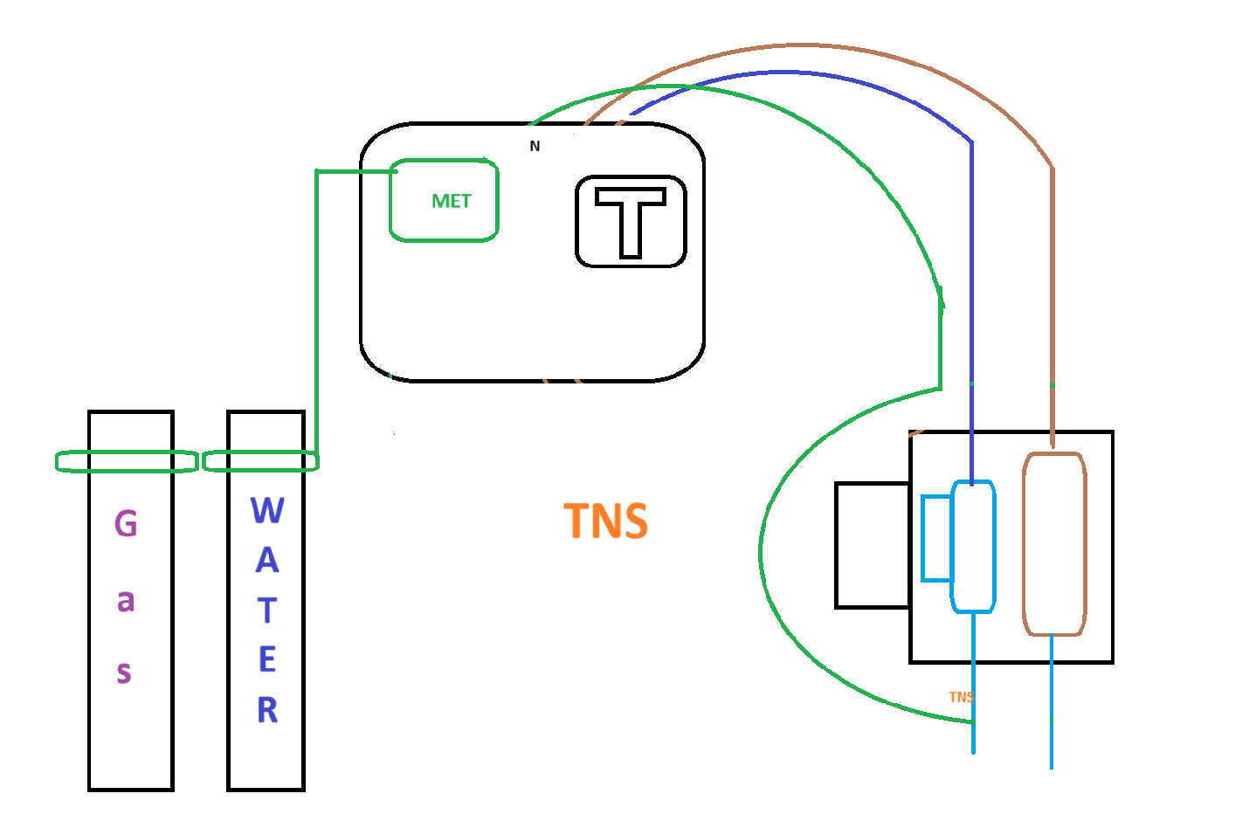

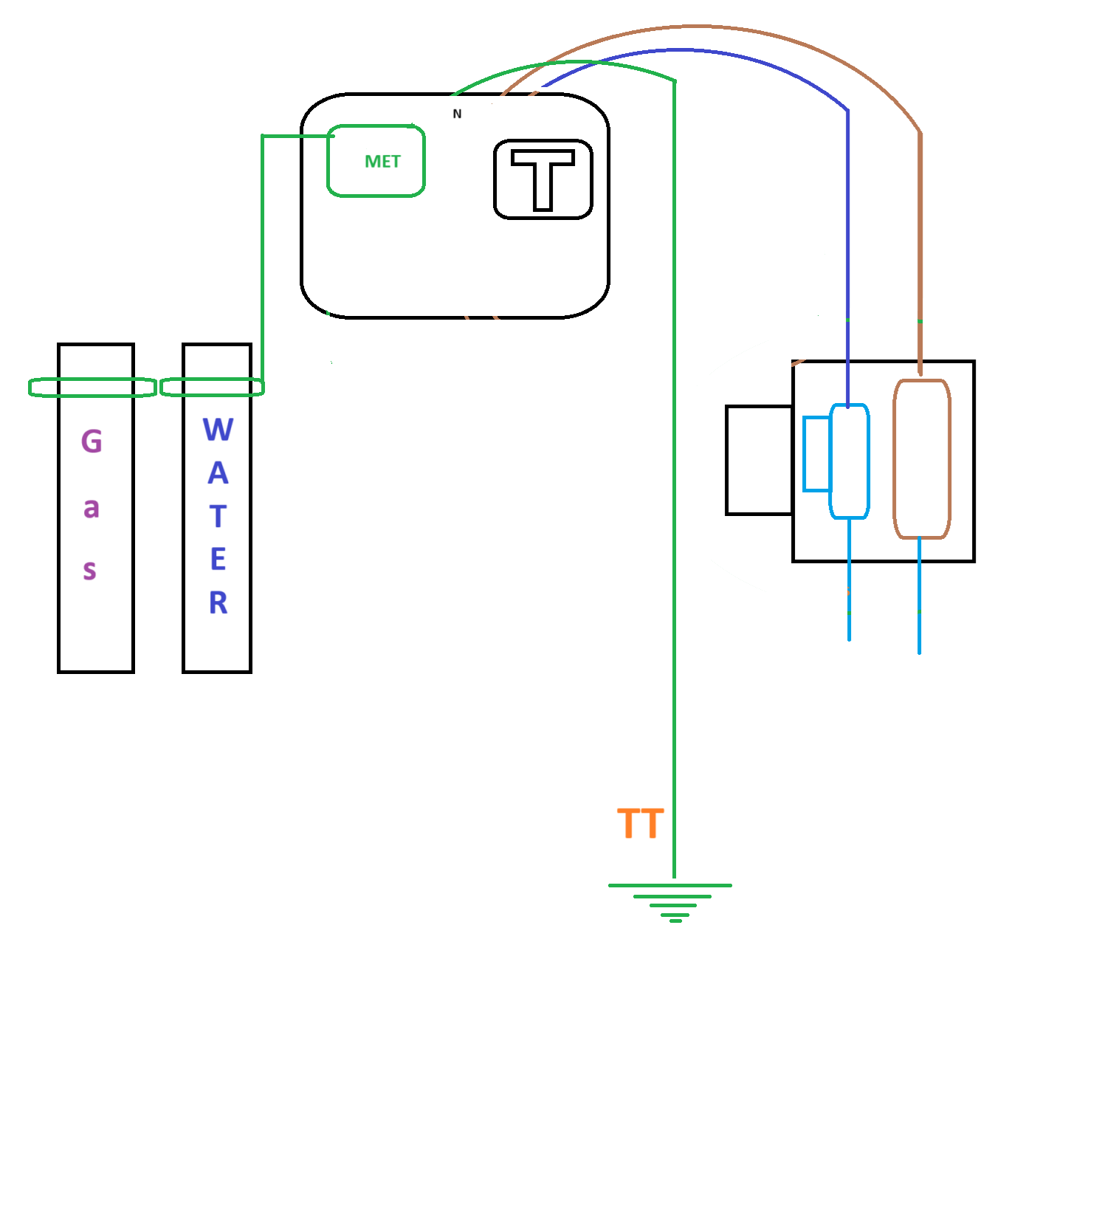

# Example One: Trunking calculation

**Using Table E5 we look-up the PVC BS 6004 cable factor based on the “Conductor cross-sectional area(mm²)”**

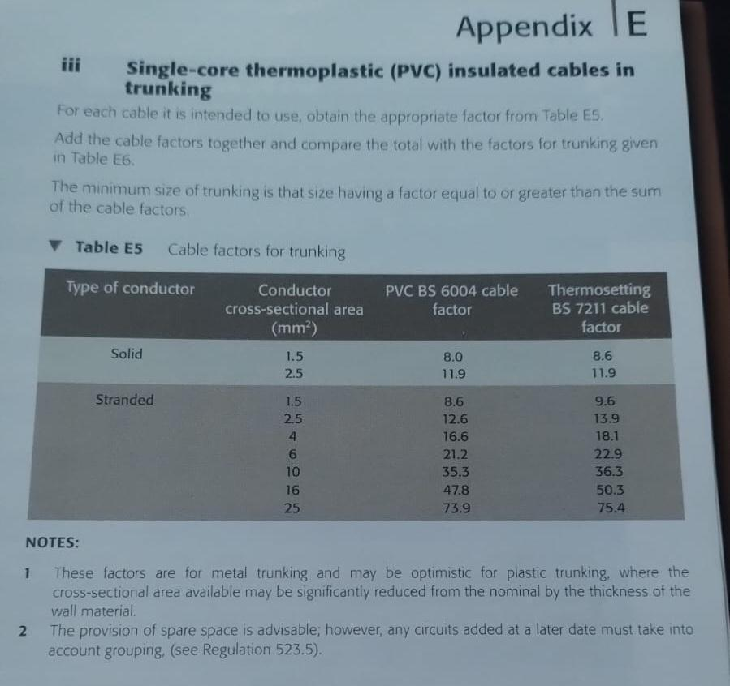

**Note down how many cables will be used in the trunking.**

|  | **Size of Cable (mm²)** | **PVC BS 6004 cable factor** | **No. of wire** | **No. of circuits** | **Cable factor** |
| --- | --- | --- | --- | --- | --- |
| **Lighting circuit** | 1.5mm² | **8.6** | **3** | **4** | **103.2 (8.6x3x4)** |
| **Sockets** | 2.5mm² | **12.6** | **6** | **6** | **453.6 (12.6x6x6)** |
| **Waterheater** | 4mm² | **16.6** | **3** | **4** | **199.2(16.6x3x4)** |
| **Car Charger**  **(3 phase circuit + Neutrel)**  **3 lines + N + E** | 6mm² | **21.2** | **5** | **1** | **106(21.2x5x1)** |
| **Ovens** | 16mm² | **47.8** | **3** | **2** | **286.8(47.8x3x2)** |
| **Shower** | 10mm² | **35.3** | **3** | **2** | **211.8(35.3x3x2)** |
| **Sum of the cable factors** | | | | | **1360.6** |

**What 1360.6 represents is the sum of the cable factors/total cable factor.**

**Next we go to page 166 Table E6. Because we want to determine the trunking factor.**

**We perform a “look-up” of the trunking factor based on the total cable factor.**

**There are multiple-right answers, however we use this criteria to decide what size trunking to use:**

***“The minimum size of trunking is that size having a factor equal to or greater than the sum of the cable factors.”***

**Which in simple terms means the:**

**Trunking factor ≥ Sum of the cable factors.**

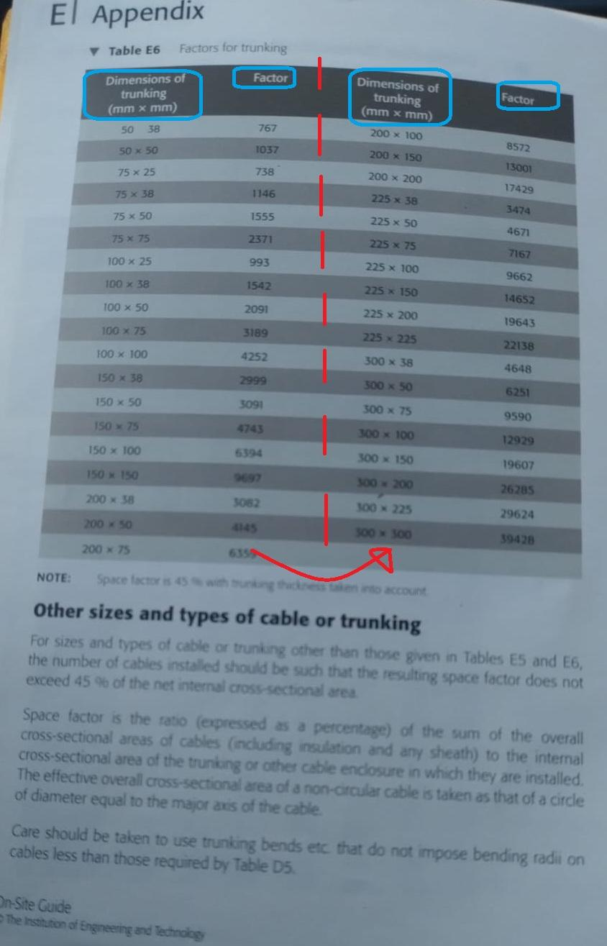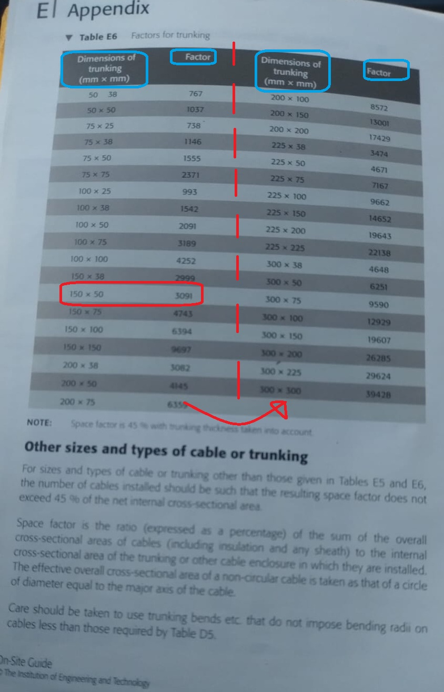

**There are multiple right answers that satisfy our criteria.**

**As long as the trunking factor is >1360.6 (Sum of the cable factors) then the answer will be acceptable.**

**The answer we selected from Table E6 is the row with:**

| **Dimensions of trunking (mm X mm)** | **Factor** |
| --- | --- |
| **150 X 50** | **3091** |

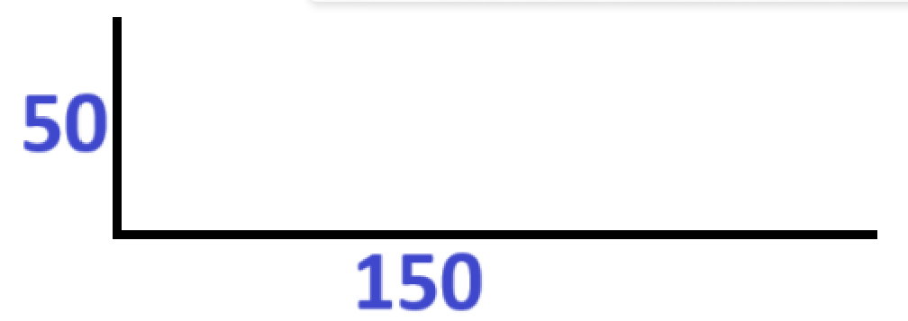

# Example one: Conduit Calculations

Remember that we must calculate:

1. **cable factor**
2. Then we perform a “look-up” of the **conduit factor** based on the **cable factor**.

**Side note:**

* **Table E1 goes with Table E2**
* **Table E3 goes with Table E4**

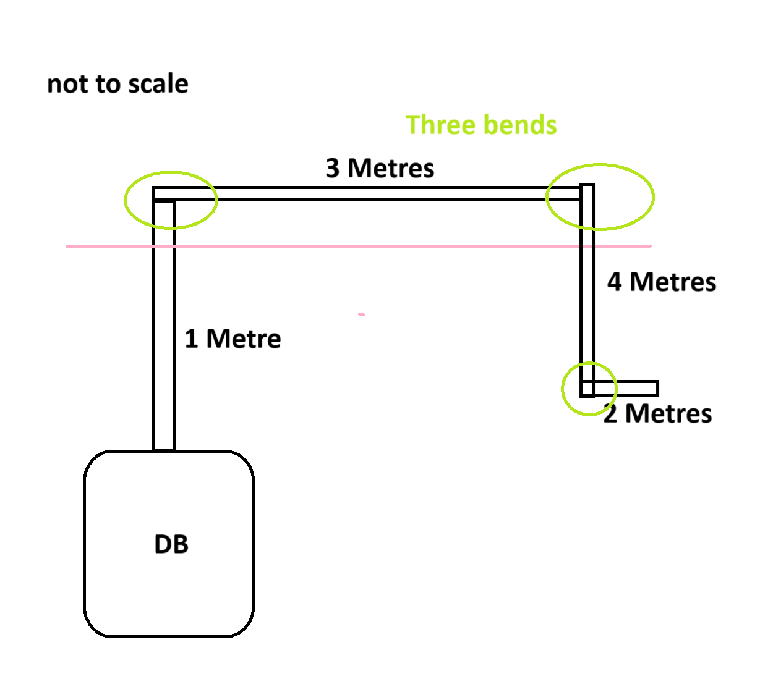

**Circuit Information**

**We have a cable:**

* **10 metres in length total => 1 + 3 + 4 + 2**
* **3 bends.**

**For conduit calculations we look at Table E4.**

**Nothing in Table E4 corresponds to a circuit that is ten metres in length with three bends.**

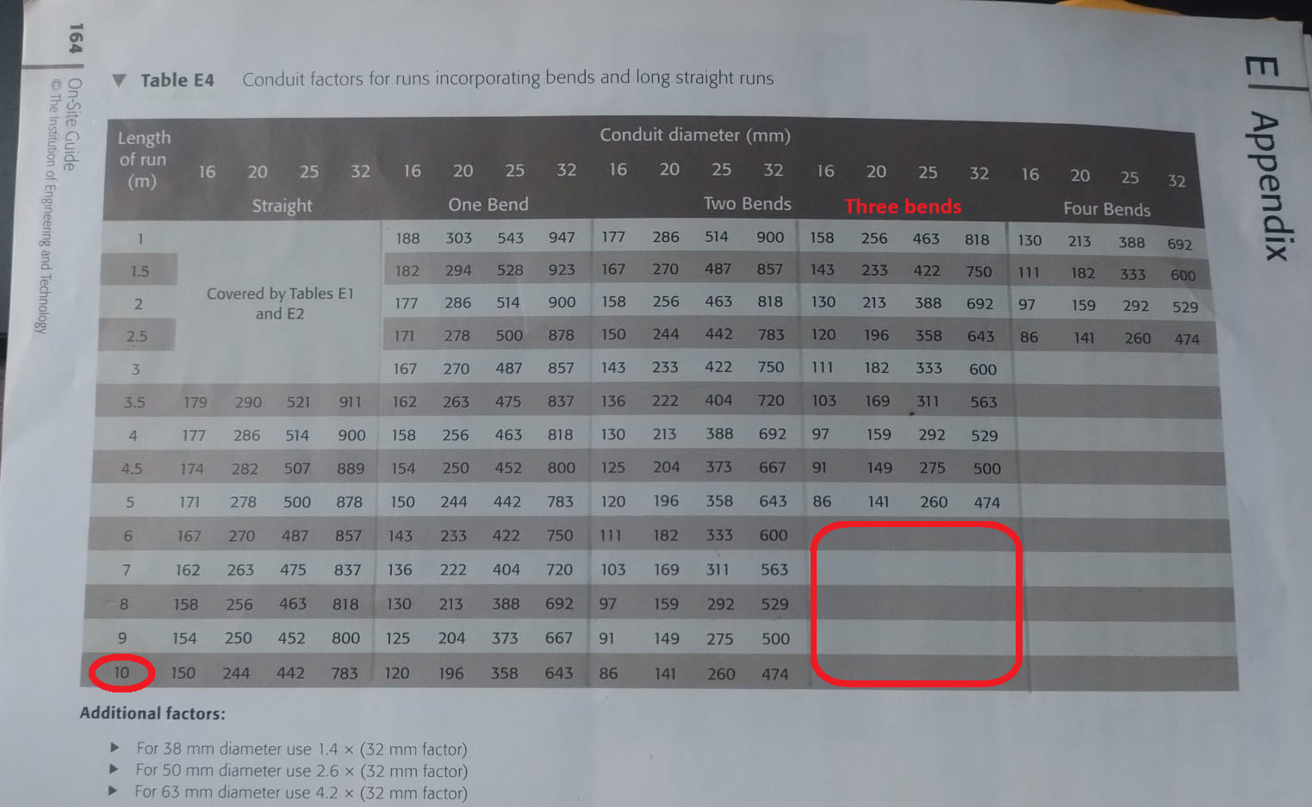

**However, if we adjust the circuit to:**

**Amended circuit information:**

* **three cables of size 2.5 (mm²) (size = conductor cross-sectional area (mm²));**
* **1 + 3 + 4 = 8 metres. An 8 meter long run.**
* **Then there is an angle box, followed by another 2 metres.**

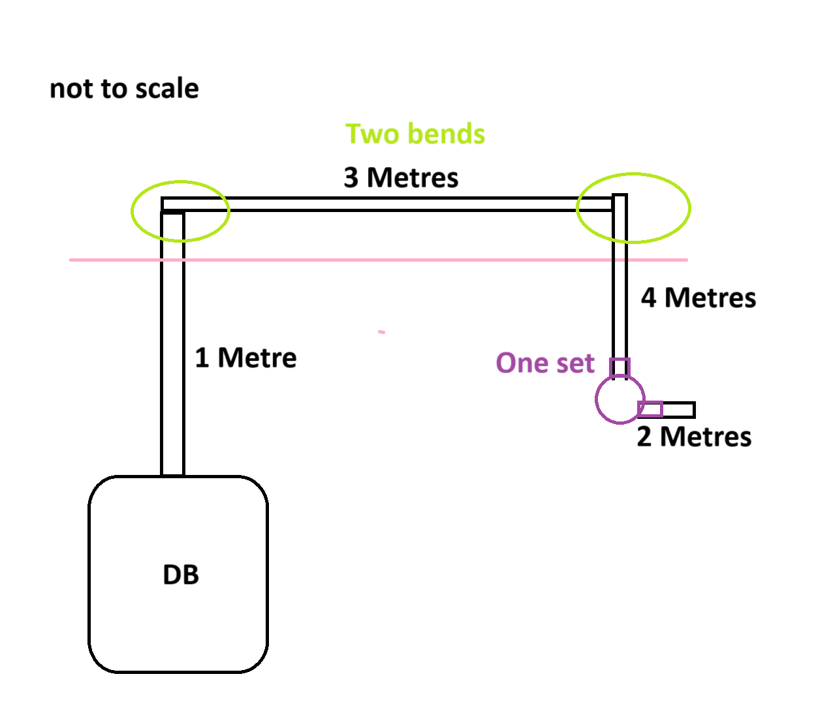

**Part A: Cable factor calculations**

**To answer this question first look at Table E3. But specifically, the column “Conductor cross-sectional area (mm²)”.**

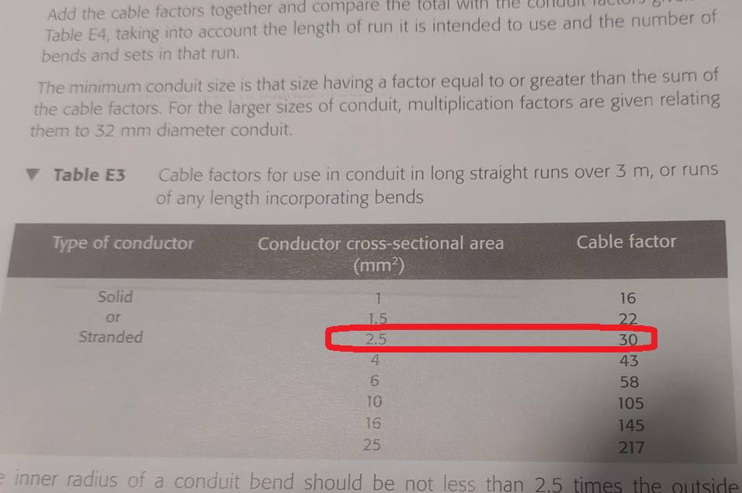

| **Conductor cross-sectional area (mm²)** | **Cable factor**  **(for a single cable)** | **No. of cables** | **Total Cable factor** |
| --- | --- | --- | --- |
| **2.5 mm²** | **30** | **3** | **90 (30 X 3)** |
|  |  | **Sum of cable factor** | **90** |

**cable factor which is 90.**

**Part B: conduit calculations**

***“The minimum conduit size is that size having a factor equal to or greater than the sum of cable factors”***

**Which in simple terms means:**

**Conduit factor ≥ sum of cable factor**

**This means our conduit factor has to be equal to or greater than the sum of cable factor which is 90.**

**We now refer to Table E4 (page 164) for conduit calculations.**

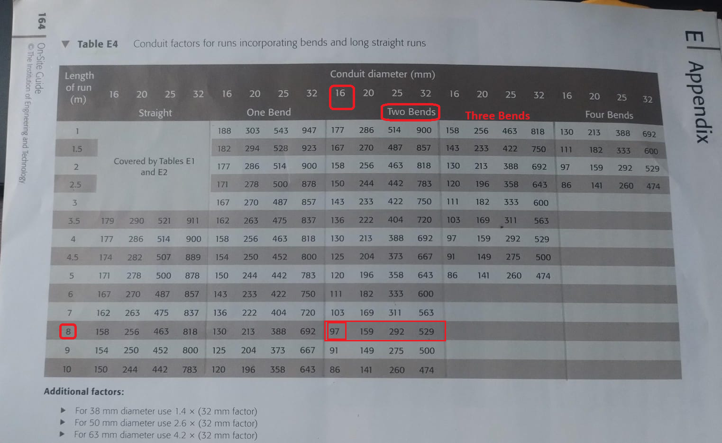

**Look at the row which has the value 8 for the column “Length of run (m)”**

**Remember we have two bends and one set.**

**The total cable factor is 90. We use the total cable factor to look-up the conduit factor. Which will be 97. because it is states:**

***“The minimum conduit size is that size having a factor equal to or greater than the sum of cable factors”***

**The reason we select 8 for the column “Length of run (m)” is because that is how long our circuit is before the set (stop & start). There is another 2 metres after the set. However, for those last two metres the conduit factor will be 16mm as well. Our calculation applies to the whole circuit. 16mm is large enough for 2 metres.**

# Final example Conduit calculation

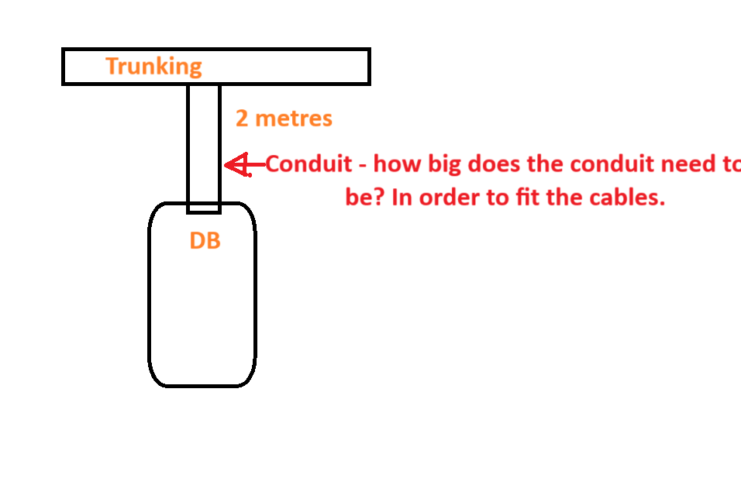

**Step one**

**We use Table E1 to get the cable factor based on the Conductor cross-sectioned area mm².**

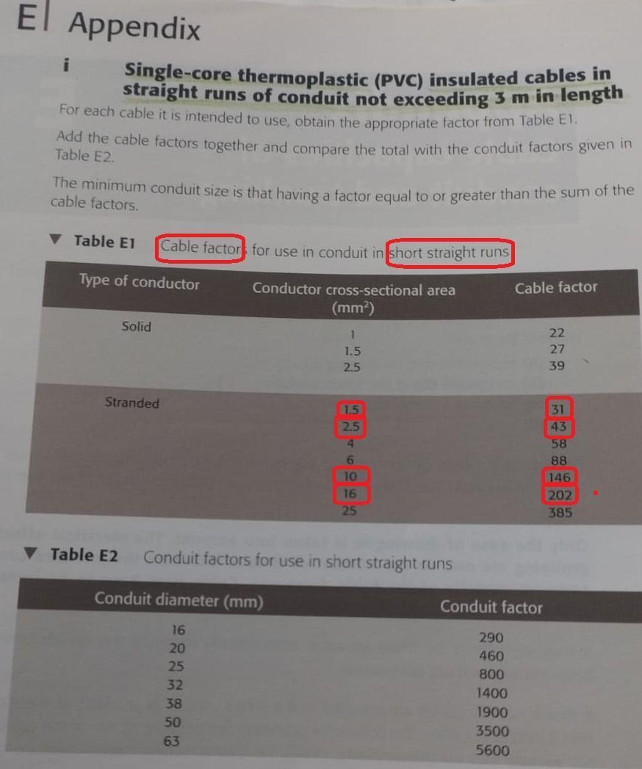

**Step two**

**Note down how many cables will be used in the conduit.**

| **Conductor cross-sectional area (mm²)** | **Cable factor** | **No. of cables** | **Total** |
| --- | --- | --- | --- |
| **16 mm²** | **202** | **2** | **404 (202 X 2)** |
| **10mm²** | **146** | **1** | **146 (146 X 1)** |
| **1.5mm²** | **31** | **3 X 2** | **186 ((31 X 3) X 2)** |
| **2.5mm²** | **43** | **3** | **129 (43 X 3)** |
|  |  | **Total cable factor** | **865** |

**When we add up all of the cable factors. We get the total cable factor.**

**We use the total cable factor to “look-up” the conduit factor on Table E2.**

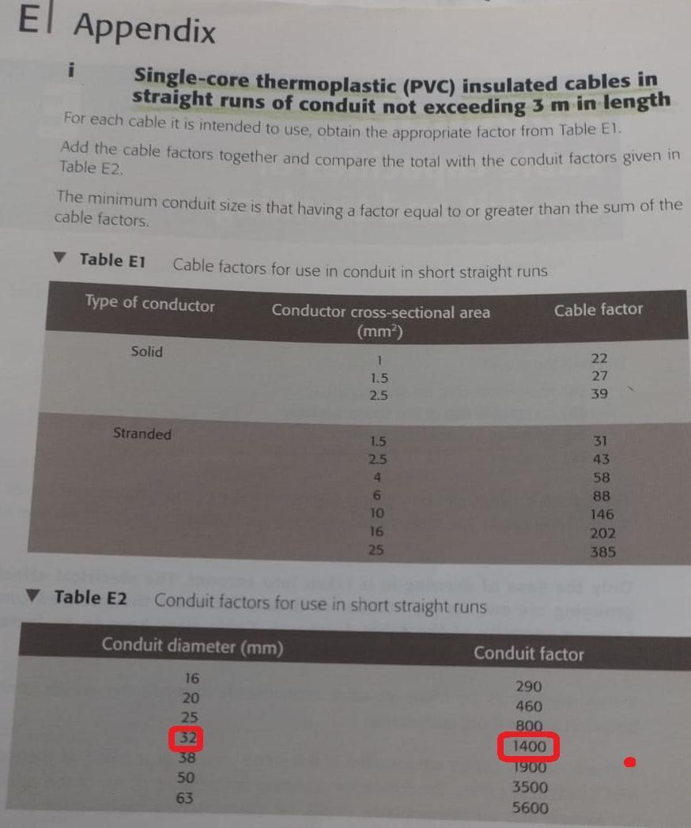

**We have to round up to the nearest whole value so 865 goes to 1400.**

**The conduit diameter is hence 32 mm.**

**Extra step**

**Because there is an excess. By excess, I mean we calculated the total cable factor to be 865. However, because it is over the 800 conduit factor we had to place into the 1400 bracket. So we can use two tails on trunking.**

**First tail**

**404 + 146 = 550**

**25mm Conduit**

**Second tail**

**186 + 129 = 315**

**20mm Conduit**

**Why - because these cables are similar in sizes would be more likely to run these cables together.**

**This approach could be considered as more optimal than having all four cables in a 32 mm conduit.**

# Practical workshop write-up Section

**Insulation resistance needs to be >200ohms.**

**We perform two insulation resistance tests. One on Live and neutral wires. The second test on Live and Earth wires. If either of the latter two cases happens this is classified as a fault within the circuit.**

**Remember a fuse will trip on two conditions:**

* **there is a fault in the circuit**
* **or if there is an overload.**

**A fault is classified as when Live touches Neutral. Or Live touches Earth.**

**>200ohms means that the wires are not touching each other inside the circuit.**

**Because when we have high resistance there is no current. Hence, there is no current flowing between the wires.**

**Continuity test for a radial circuit test**

**Continuity checks that the circuit is complete.**

**(R1 + R2) means (Live + Earth)**

**Which means we get the Live wire and add it to the Earth Wire. Which in a practical sense means we move the Brown live wire into the connector block inside the fuse box.**

**We need to test the furthest Current Using Device (CUD) from the fuse box. We attach one probe to the earth terminal of the furthest CUD. Attach the other to the Live terminal of the Furthest CUD.**

**On the electrical tester place the setting on Continuity and hit test.**

# 

# Picture of the board

**This was the board at the start of lesson 13.**

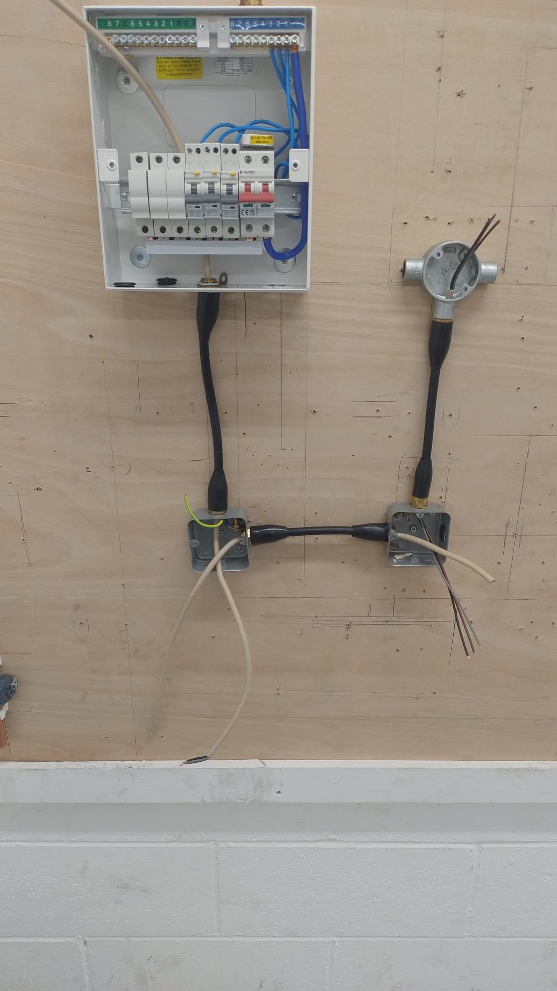

# Testing R1 + R2 - How does the Fuse board look?

**The fuse box. Ignore the green and yellow. Because, in this board we used the brown live wire and the grey wire as earth.**

**The reason why we put the brown live wire and the grey wire into the connector block is because we are testing for (R1 + R2).**

